LANCASHIRE AND CHESHIRE AMATEUR FOOTBALL LEAGUE
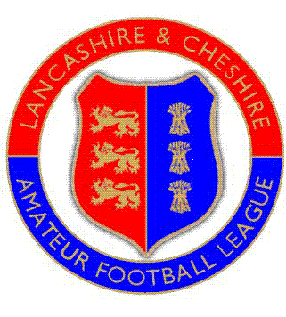
Company Secretary: Brian Davies
Pinfold Barn, Lymm Rd, Thelwall, Warrington, WA4 2TG
Tel: 01925 751400
e-mail: secretary@landc.org.uk
web site: www.landc.org.uk

29 July 2026

To all League Clubs and Committee members

Control of Alcoholic drinks and use of drugs at Football Grounds

Dear Secretary,

The league committee wishes to make clear its stance on the drinking of alcoholic beverages and the use of drugs in the vicinity of football pitches used in the league.

It is unacceptable for alcohol to be consumed on the touchline at any L & C match. If alcohol is available at the club it must remain within the clubhouse. Furthermore, there shall be no glasses or cans anywhere near the pitch or dressing rooms, as broken glass can be extremely dangerous in areas used for sporting purposes.

The use of drugs (including social drugs) is not permitted in sporting areas, just as in any other place, subject to the law. The FA Doping Control procedures apply to this league, as they do to any other, and testing can be ordered by the FA or its agents (the League) without warning.

Club and League officials must remain vigilant and challenge any participants or spectators who are ignoring or are unaware of these controls.

Kind regards,

Brian Davies
League Secretary

Safe Whistling Award
Lancashire and Cheshire Amateur Football League Limited Registered in England 3049324
Registered Office c/o Parker Gradwell & Co., 17 Chapel Street, Hyde, Cheshire SK14 1LF

